AI ASSISTED CODING
ASSIGNMENT-6.5
NAME: Mohammed Adnan Awaise
H.T.NO:2303A52244
BATCH:36

Task Description #1 (AI-Based Code Completion for Conditional
Eligibility Check)
Task: Use an AI tool to generate eligibility logic.
Prompt:
“Generate Python code to check voting eligibility based on age and
citizenship.”
Expected Output:
• AI-generated conditional logic.
• Correct eligibility decisions.
• Explanation of conditions.

Code:
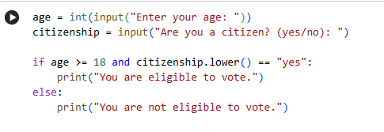
OutPut :
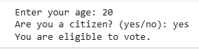

Explanation :
- age = int(input(...)): Takes the user’s age as input.
- citizenship = input(...): Takes citizenship status.
- if age >= 18 and citizenship.lower() == "yes":
Checks both conditions:
  - Age must be 18 or above
  - Citizenship must be “yes”
- Prints eligibility result based on conditions.

Task Description #2(AI-Based Code Completion for Loop-Based
String Processing)
Task: Use an AI tool to process strings using loops.
Prompt:
“Generate Python code to count vowels and consonants in a string
using a loop.”
Expected Output:
• AI-generated string processing logic.
• Correct counts.
• Output verification.

Code :
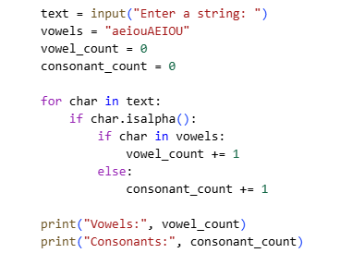
Output :
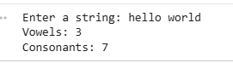

Explanation :
- Loops through each character in the string.
- isalpha() ensures only letters are counted.
- Vowels are checked using a predefined string.
- Counts vowels and consonants separately.

Task Description #3 (AI-Assisted Code Completion Reflection
Task)
Task: Use an AI tool to generate a complete program using classes,
loops, and conditionals.
Prompt:
“Generate a Python program for a library management system
using classes, loops, and conditional statements.”
Expected Output:
• Complete AI-generated program.
• Review of AI suggestions quality.
• Short reflection on AI-assisted coding experience.
Code :
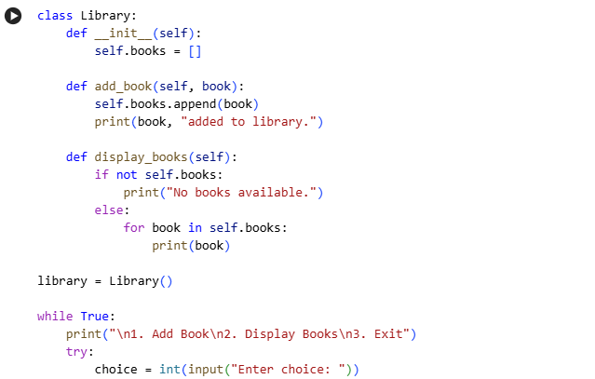
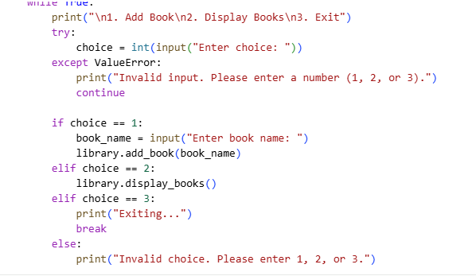
OutPut :
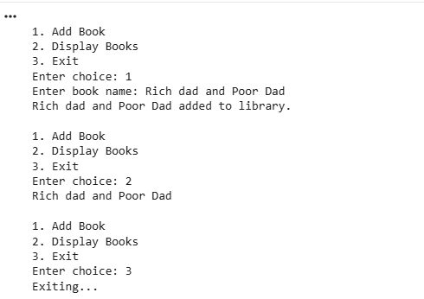

Explanation :
This program uses classes, loops, and conditional statements to manage a small library.
- A class Library is created to store and manage books.
- The __init__() method initializes an empty list to store book names.
- The add_book() method adds a new book to the library.
- The display_books() method shows all available books using a loop.
- A while loop displays a menu repeatedly until the user chooses to exit.
- Conditional statements (if-elif-else) handle user choices like adding or displaying books.

Task Description #4
Prompt: “Generate a Python class to mark and display student
attendance using loops.”
Code :
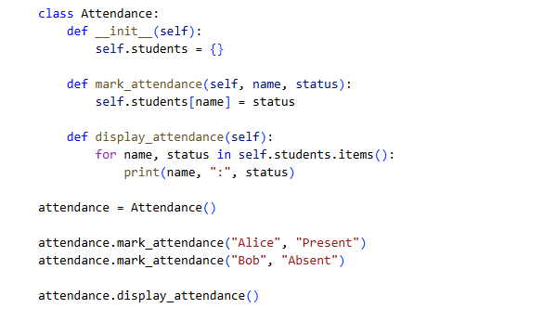
OutPut :
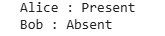

Explanation :
- Uses a dictionary to store student names and attendance.
- Loop displays attendance for all students.
Task Description #5 (AI-Based Code Completion for Conditional
Menu Navigation)
Prompt: “Generate a Python program using loops and conditionals
to simulate an ATM menu.”
Code :
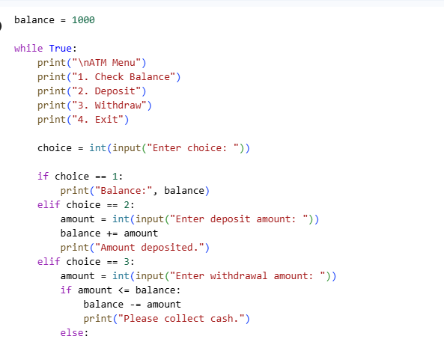
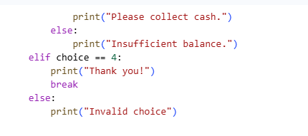
OutPut :
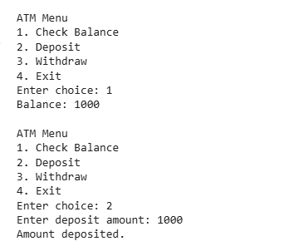
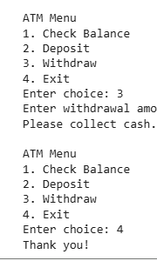

Explanation :
This program simulates an ATM system using loops and conditionals.
- A variable balance stores the current account balance.
- A while loop keeps the ATM menu running until the user exits.
- The menu offers four options:
  - Check Balance
  - Deposit Money
  - Withdraw Money
  - Exit
- Conditional statements process the selected option.
- Withdrawal checks if sufficient balance is available before allowing the transaction.

